Curriculum Vitae
personal Information
Name | Hany Ahmed El-Haback | 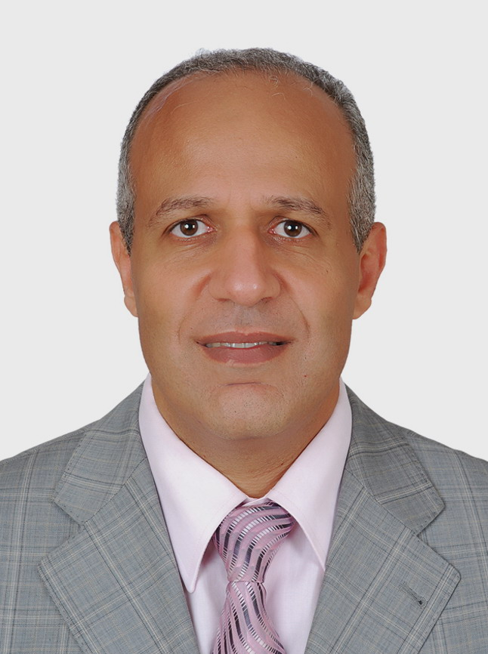  optional photo
Title | Professor
Date of birth | 9/4/1963
Place of birth | Cairo
Citizenship | Egyptian
Contact Information
Home phone | 22729545
Work phone | 35720799
Mobile phone | 01110044778
E-mail (s) | hanyhaback@yahoo.com
Web site (s)
Current Address | Dept. of Histology & Cytology, Faculty of Vet. Med., Cairo university, Giza
Educational Qualifications
- Master in Cytology & Histology 1990 (Histology and Histochemical studies on the oviduct of Pikin ducks)

- PhD in Cytology & Histology 1995 (Posthatching development of the liver of Tilapia Fish (oreochromis Niloticus) with special reference to diet and insecticide effect. External channel with USA, Virgenia Tech. Diploma.

- "Human Resources" College of Cambridge, 2010
- Training of the trainer Cairo University".

Academic Positions
- Lecturer of cytology & Histology, faculty of veterinary medicine, Cairo university 1995.

- Ass. Prof. of cytology & Histology, faculty of veterinary medicine, Cairo university 2000

- Professor of cytology & Histology, faculty of veterinary medicine, Cairo university 2008.
- Head of department of cytology & Histology, faculty of veterinary medicine, Cairo university 2010.
- Certified trainer in FLDC Cairo University 2009.
- Director of training & Development Unit at the Faculty of Vet. Med., Cairo university.

Thesis Title
- Some morphological studies on the digestive system of tilapia fish (2006) (Master)

- Histological studies on some organs of immune system of Nile Tilapia Fish (Oreochromis Niloticus)

- Histological, Histochemical and Electron Microscopic Studies on Testis of gilthead sea bream (Sparus aurata) (2007) pH.D.

- The effect of natural immunomodulator on GALT (gut associated lymphatic tissues of broiler, Histological, Histochemical and electron (2009) (Master)

- postnatal studies on the mucosa of rabbit stomach (2010) (Master)

- Studies on the Harderian gland of rabbit. (2012) pH. D

Areas of experience
- Academic teaching of histology
- Academic research work and supervision
- Soft skills training

Projects
Awards
Professional Qualifications
Conferences
- American veterinarian Association 1994
- The Egyptian society of histology and cytology

Training courses
- Professional using of Transmition Electron microscope (USA, 1993)
- Professional using of Scanning Electron microscope (USA, 1993)
- Training of trainer RDC, Los Angles, California (USA, 2001)
- "Human Resources" College of Cambridge, 2010
- Training of the trainer Cairo University, 2010
- CORT program of DE BONO, FLDC, 2012

Computer Skills
- Word
- Powerpoint
- Photo editing
- Mind maping
- Excel sheet

Language Skills
- English
- Arabic

Professional Memberships
- Member of AVA (American Vetrinarian Association)
- Member of The Egyptian society of histology and cytology
- Member of Arab Trainer Association

Other activities
- Paper Judgments:
Seasonal histology and histochemistry of the adenohypophysis, testis and ovaries of Nile tilapia (oreochromis niloticus) (2011)
Effect of Red Bull energy drink on the Rats' submandibular salivary glands. Journal of Advanced Research, April, 2011. (International Journal)
Histo-morphological study of the tongue and lingual papillae of Egyptian local breed goat. Journal of Advanced Research, November, 2010. (International Journal)
- Sharing in General Histology and System Histology of department book.

- Coloured Atlas of Histology.

- Setting up with Prof. Gehad Abd Al-Fatah the project (Step by Step electronic Histology Drawing, 2011)

List of publications
- HANY AHMED EL- HABBACK (1999).
Intranuclear bodies and other cytomorphologic features of the horse jejunum mucosa.
Vet.med. j. Giza. 47(4): 537-547

- S.d.hollday, S.A. Smith, Hany A. El- Habback And T. Caceci (1996)
Influence of chlorpyrifos, an organophosphate insecticide, on the Immune system of Nile Tilapia.
Journal of aquatic animal health 8:104-110.

- T. Caceci, H.A. EL- HABBACK, S.A. Smith and B.J Smith (1997)
The stomach of oreochromis niloticus has three regions.
J. Fish Biology 50:939-952

- Hany A. El- Habback, H.E. Marei and G.A. El- Bargeesy (1997)
The possible origin and function of rodlet cells in oreocchromis niloticus. Egypt. J. Histol. 20(1) : 135-150

- Hany A. El- Habback and Thoria Salam (1998)
Developmental studies on the Trachea and Extrapulmonary bronchi of rabbit.
The new Egyptian journal of medicine. 19(4): 231-241

- Hany E.S Marei and Hany A. El- Habback (1999)
Ultrastructure of the luminal immunocompetent cells of the chiken's air passageways.
Vet. Med.g., Giza. Vol. 47(2) :277-289

- Hany A. El- Habback, S.M. El- Gharabawy And G.A. El- Bargeesy (1999).
Lingual papillae of one- Humped Camel (Camelus Dromedarius).
Histological, some Histochemical and SEM studies.
Circumvallate papillae
The new Egyptian journal of medicine. 21(1):59

- Hany A. El- Habback, S.M. El- Gharabawy and G.a. El- Bargeesy (1997).
Chloride cells of the developing gills of oreochromis niloticus fish.
Light and ultrastructure studies.
Conference 21st , The Egyptian society of histology and cytology.

- Marei , H. E. S. * and El- habback, H. A. ** (2002)
Ultrastructure of The Nonciliated Bronchiolar Epithelial (Clara) Cell In The Lungs Of Neonatal Rabbits
Mansoura, vet. Med. J. 4(2): 169-183

- H.A. El- Habback, S.A. Emara* and H.E. Marei**(2003)
Light and Electron Microscopic Studies On The Posterior Kidney Of Oreochroms Niloticus
Mansoura, vet. Med. J. 5(1): 111-132

- H.E.s. Marei* and K.F. ABOU-ESA*** (2004)
Histology, Fine Structure and Carbohydrate Histochimistry of The epithlium of The accessory Male Genital Glands of The Egyptian Baladi Goat.
Vet. Med.g., Giza. Vol. 52(2) :165-182

12- HANY AHMED EL-HABBACK (2007)
Posthatching development of the stomach of Tilapia nilotica (OREOCHROMIS NILOTICUS). Light and electron microscopic studies.
Kafrelsheikh Vet. Med. J., 5(2): 1-31

13- HANY AHMED EL-HABBACK (2007)

Ultrastructure of secretory alveoli of lactating mammary gland of one humped she-camel (CAMELUS DROMEDARIES)
Kafrelsheikh Vet. Med. J., 5(2): 32-54
14- S. M. El-Gharbawy, TH. F. Salam and H. A. El- Habback (2001)
Posthatching age changes of the oesophegus of tilapia fish (OREOCHROMIS NILOTICUS) light and TEM studies.
Vet. Med. J. Giza, 49(2): 451-472

15- H. A. El-Habback, S. A. Emara and H. E. Marei (2003)
Light and electron microscopic studies on the posterior kidney of OREOCHROMIS NILOTICUS.
Mansoura, Vet. Med. J. 5(1): 111-132

16- H. E. S. Marei and H. A. El-Habback (2003)
Ultrastructural and immunohistochemical localization of the ANP- producing cells in the heart of rabbits.
Mansoura, Vet. Med. J. 6(2): 1-23

17- Marei, H. E. S. and H. A. El-Habback (2002)
Ultrastructure of the nonciliated bronchiolar epithelial (Clara) cells in the lungs of neonatal rabbits.

Mansoura, Vet. Med. J. 4(2): 169-183

18- H. E. S. Marei; H. A. El-Habback and K. F. Abou- Esa (2004)
Histology, fine structure and carbohydrate histochemistry of the accessory male genital glands of the Egyptian baladi goat.
19.2021 Journal of Advanced Veterinary Research Rashad, E., Hussein, S., Bashir, D. W., Ahmed, Z. S. O., & ElHabback, H . (2021). Immunophenotyping Panel of T Lymphocyte in Water Buffalo Spleen (Bubalus Bubalis) And Its Significant Correlation to Ruminant Diseases. Journal of Advanced Veterinary Research, 11(2), 57-63.
20-.2021 Journal of Advanced Veterinary Research Eman Rashad, Shaymaa Hussein, Dina W. Bashir, Zainab Sabry Othman Ahmed, Hany El-Habback. Immunohistochemical Distribution Of Immunocompetent Cells In Water Buffalo Spleen (Bubalus Bubalis)
21.2020 Journal of Critical Reviews Eman Rashad, Shaymaa Hussein, Dina W. Bashir, Zainab Sabry Othman Ahmed, Hany El-Habback. Anatomical, Histological, Histochemical, Scanning And Transmission Electron Microscopic Studies On Water Buffalo (Bubalusbubalis) Spleen
22- 2016 Research Journal of Pharmaceutical, Biological And Chemical Sciences. Eman Rashad Mohamed, Hany Ahmed El- Haback, Mohamed Ibrahium Abd Rabou, Shimaa Hussein Mohamed and El-Sayed Fath khalifa, Gross anatomy and morphology of Egyptian water buffalo’s liver (Bubalus bubalis) with reference to some histochemical and immunohistochemical evaluation.
Vet. Med. J. Giza, 52(2): 165-182

Publications statistic
Journal’s Publication |  | Conference’s Publication |  | Authors |  |  | Total
Local | International | Local | International | Single | Shared |  | Total
 |  |  |  |  | Internal | External | Total
18 | 2 | 1 | 1 | 3 | 15 | 2 | 20

